Name |  | Score | Resource Free
 |  |  | Resource Assisted
 |  |  | Total

Attempt all questions and full working out must be shown to get full marks.
Total Time: 60 minutes
- Section 1 (Calculator Free): 25 minutes 24 marks
- Section 2 (Calculator Assisted): 35 minutes 31 marks

Calculator Free
Question 1 (4 marks)
Using the unit circle supplied
(a)
(i) find sin θ

sin θ = ____________

ii) draw the other angle with the same value as (i)
θ
(b)
(i) find cos θ

cos θ = ____________

ii) draw the other angle with the same value as (i)

α

Question 2 (7 marks -1,1,1,1,1,2,)

- Convert these angles into degrees:

(i)

(ii)

- Express these angles in radians

- 30º

- 210º

- State the exact value of sin (2π)

- Write down the exact values of $sin\left(\frac{2π}{3}\right)$

Simplify and express with a rational denominator:

Question 4 (8 marks)

i) Find x in simplified exact form in each of these two diagrams:
a)

- b)
x

x

ii) Find θ in each of the following two diagrams.
- b)

$$6cm$$
$$60\sqrt{3}$$
$$120cm$$

Question 5 (3 marks)

The triangle shown below has an area of 36 cm², determine the value of x.

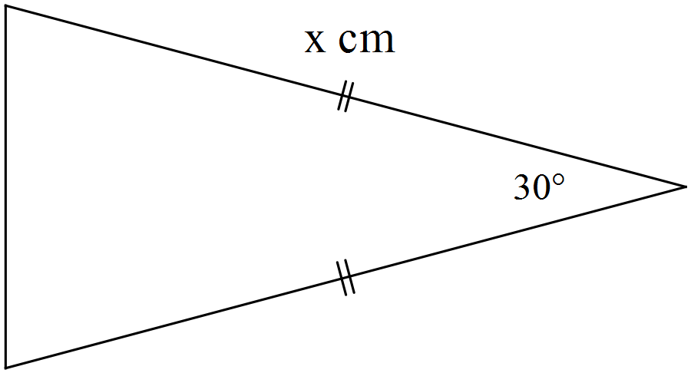

Calculator Assumed

Question 6 (2 marks)

Determine the equation of the linear function shown below. All values should be expressed in exact form.
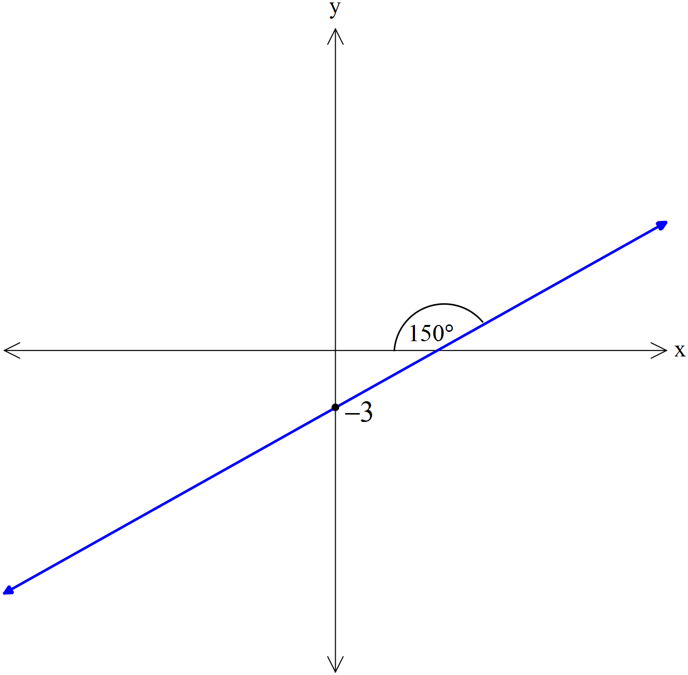
Question 7 (6 marks)
Determine, correct to 2 decimal places, the length of side BD in the diagram below.
Note: Diagram not drawn to scale.
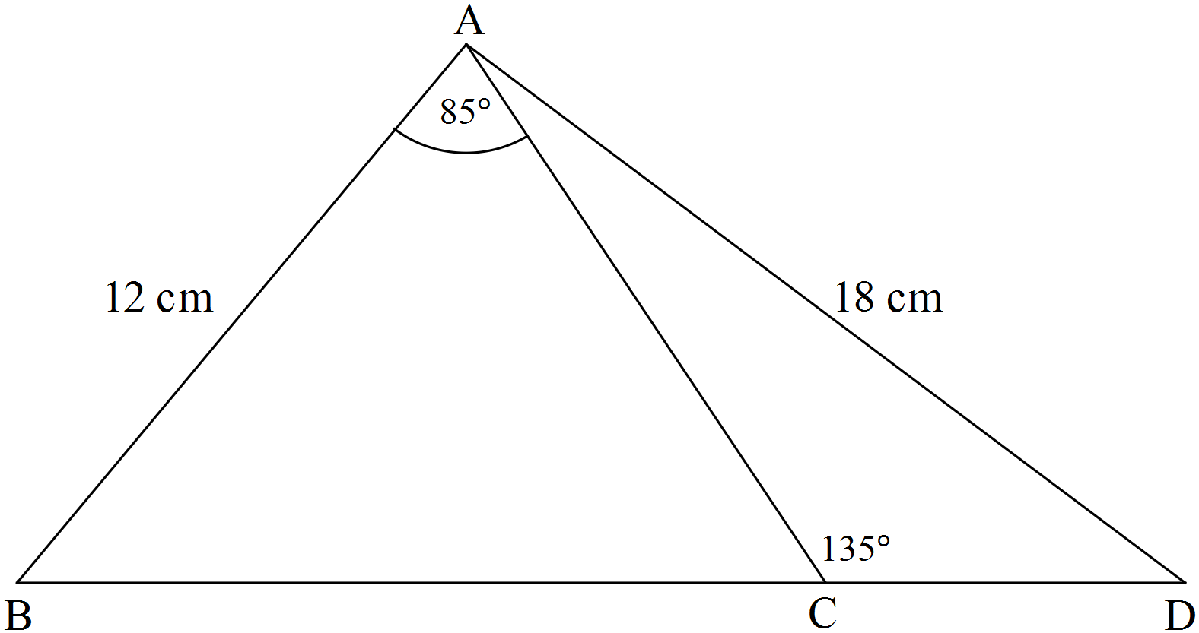

Question 8 (8 marks)

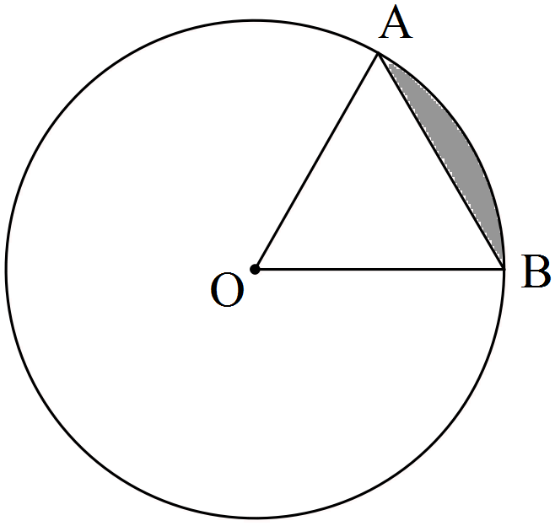The circle shown with centre O has a radius of 3π cm.
If the size of ∠AOB = 60°, determine the
(a) area of triangle AOB as an exact value in terms of π.

(b) length of the major arc AB accurate to 2 decimal places. (2 marks)

(c) area of the minor sector AOB to the nearest cm². (2 marks)

(d) area of the minor segment (shaded) formed by the chord AB accurate to 3 significant figures. (2 marks)

Question 9 (5 marks)

Triangle ABC drawn below has sides of 32 cm, 46 cm and 48 cm. The circle with a radius of 11 cm is inscribed inside the circle and just touches the three sides of the triangle.

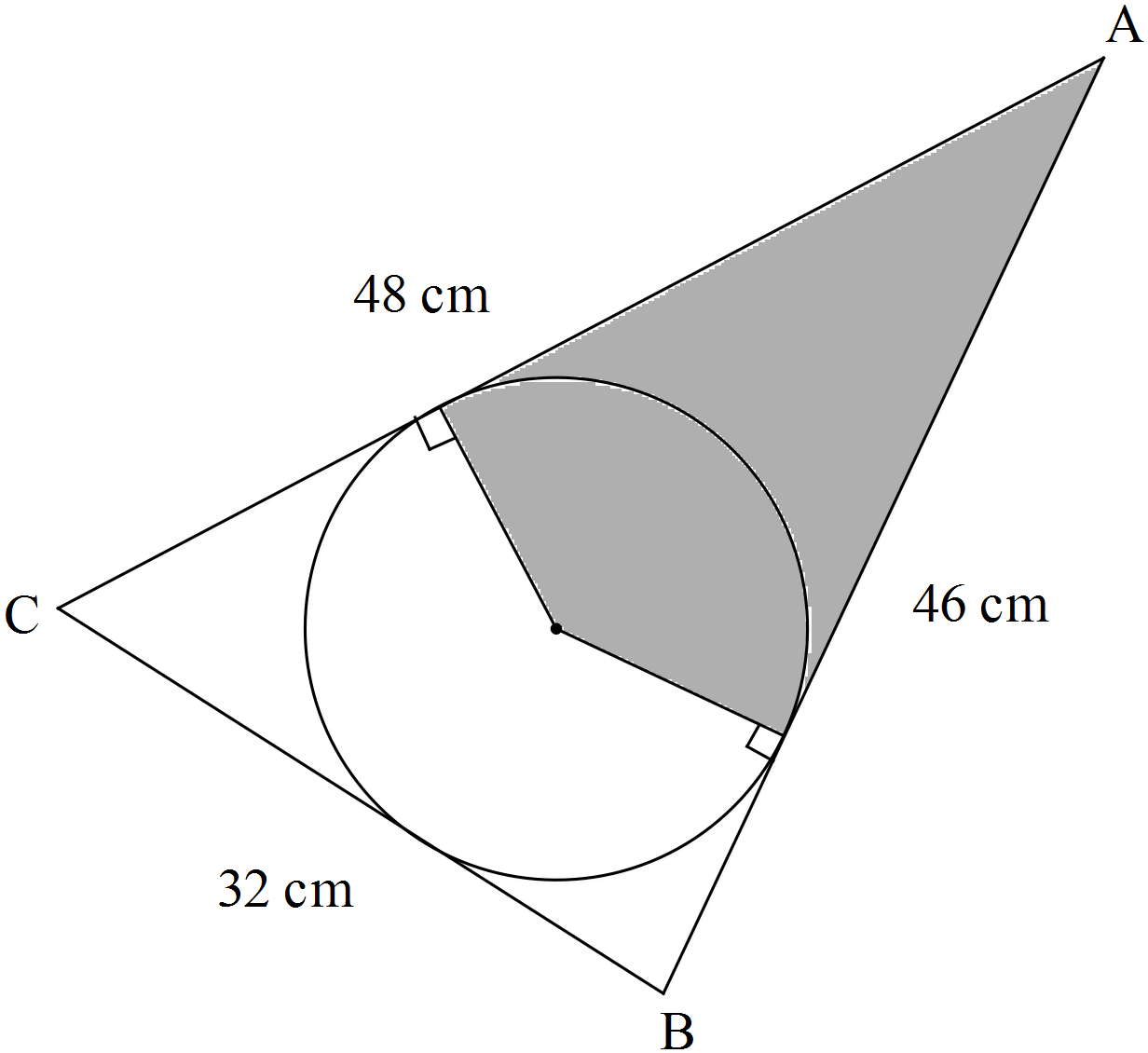
Note: Diagram not drawn to scale.
Determine the area of the shaded region. (Hint: First find the size of ∠BAC).

Question 10 (10 marks)

The diagram below shows a pair of intersecting circles with centres at P and Q with radii of 5 cm and 6 cm respectively. RS is the common chord of both circles and PQ is 7 cm.

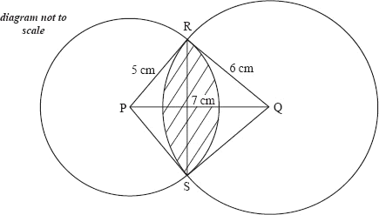

Find the area of the shaded region.

End of Test

